**Filtering Signals for Hospital Navigation and Localization**

Tamby S.[1], Hon B.[2], Tay A.[3], Yen S-C.[4]

*Department of Electrical and Computer Engineering, National University of Singapore*

*21 Lower Kent Ridge Road, Singapore 119077*

**ABSTRACT**

In today’s technological world, outdoor navigation systems such as Google Maps have allowed people from all over the world to easily localize a person or place. However, the accuracy of such technology for indoor navigation has yet to reach the level of outdoor navigation. This project involves using Bluetooth Low Energy beacons for an indoor localization system. Devices including Intel Edison and Bluetooth beacons are used to estimate a patient’s location within a hospital. Specifically, this paper address the different approaches in filtering the noisy signals received from the beacons. Various filters were used on raw RSSI signals to estimate a more accurate distance between the Intel Edison and the beacon.

**INTRODUCTION**

The need for an indoor localization system is particularly prominent in places in need of high-level security. In a hospital setting, the benefits of an indoor localization system are widespread. For example, data such as the stream of patients, bed allocation, and the staff’s easy access to statistical data are all patient services that could be streamlined using the hospital navigation and localization application5. This research focuses on using Bluetooth Low Energy (BLE) beacons for indoor localization in a hospital environment. The infrastructure exists on the patient’s device, the service, and an iPad app. An Intel Edison board acts as a patient device and reads Bluetooth and Wifi signals. The staff is then able to access this information via an iPad iOS application. These signals are sent to a server that converts data in the form of RSSI (Received Signal Strength Indicator) values into an estimated location using the distance path loss model. A higher RSSI value corresponds to higher signal strength, thus indicating that the distance between the object and the beacon is small. The larger the distance between the objects, the lower the signal strength will be. The RSSI signals are often very noisy, meaning that there is a large discrepancy between the actual RSSI value and the RSSI output measured. The noise occurs because RSSI values are highly dependent on environment so signals bounce against objects in the environment, such as walls and furniture. Thus, this research paper focuses on analyzing the accuracy of the distance model and applying a filter to predict a more accurate location of the signal.

**LITERATURE REVIEW**

Many literature journals were thoroughly analyzed to understand and apply a variety of filters to the raw data.

Indoor localization techniques

The article *Evaluation of indoor positioning based on Bluetooth Smart technology*3 from Chalmers University of Technology discusses various positioning techniques and analysis on RSSI measurements to best estimate position. The techniques most applicable to the indoor localization project include fingerprinting and triangulation. There are two phases with fingerprinting: an offline and an online phase. First, the map of the indoor area is separated into grid-cells with each cell associated with a unique attribute. A fingerprint database is constructed so the online phase can determine the position based on the various values in the database. For example, if RSSI value is used as the attribute, then the node collects RSSI values from various beacons in the range and compares them with the rest of the fingerprints in the database. The process of triangulation gets angles to and from certain points of reference. These known reference points form a triangle and use the angle of arrival to determine the intersection point of the three circles.

RSSI analysis

The article further describes how in order to analyze these RSSI values, there are many factors taken into account. First, there is a correlation between distance and average RSSI value. As the RSSI value becomes more negative, the signal strength is weaker, thus indicating the distance between the object and the Bluetooth beacon is getting larger. Also, the RSSI variance should not increase with distance, but will oscillate up and down as the distance increases.

Challenges with RSSI measurements

This article also discusses the many challenges facing this method for performing positioning. First, there is only a correlation between distance and RSSI when the beacon and the positioning device are in close proximity. The variance that exists in the RSSI values also contributes to a very noisy signal and estimated positioning. The variance can be due to the angle and obstacles that can both have a large impact on the measured values. For this reason, RSSI measured values vary based on the environment. Next, the RF (radio-frequency) devices used to measure RSSI are extremely sensitive to even the smallest irregularities in chip constructor. Thus, the RSSI values are not consistent from each device. It is important to establish a baseline value to determine how RSSI values change.

Finite Impulse Response Filter

The second article from the University of Zurich4 describes how the finite impulse response filter is helpful in filtering noisy signals. The FIR filter is a filter of order *n* that estimates an output using a weighted sum of previous input values. Each input value has a unique coefficient that remains constant. The actual input values work like a queue in that they keep getting popped because only the most recent inputs are used to determine the next output.

Kalman Filter

The third article titled *Kalman filters explained: Removing noise from RSSI signals*1explains how one method to filter raw data is to remove noise using Kalman filters. This filter translates the raw RSSI measurements into distance using the Log-Distance pathloss model. The equation is as follows:

$RSSI= -10n\log_{10}{\frac{d}{d_{0}}+A_{0}}$ (1)

Generally, n represents the signal propagation exponent and is a constant 2. A0 is the referenced RSSI value at d0 (the initial distance) and changes depending on which beacon the data is being collected from. For example, when d0 is equal to 1, A0 represents the signal strength at a distance 1 meter from the device. The variable d represents the distance between the beacon and object. The Kalman filter is a state estimater that makes an estimate of the current position based on noisy measurements. This filter implements a recursive algorithm that takes into account this history of previous measurements to estimate the true value. This iterative process can be used as a simple filter for a one-variable example in which there is constant input with noise. The filter would take into account the consecutive data inputs to estimate a single true value.

The follow-up article titled *Lightweight Javascript library for Noise filtering use Kalman filters*2explains a python based implementation of the Kalman filter. The process of estimating the true value starts by calculating the Kalman gain. The Kalman gain is how much of a new measurement should be used to calculate the new estimate. The formula is as follows:

$Kalman gain=\frac{Error in estimate}{Error in estimate+Error in measurement}$ (2)

For the base case of the first estimate calculation, the error in estimate and error in measurement are picked by the user. With this filter, the initial estimate can be of any value because the Kalman filter will narrow the guess to correct numbers quite quickly. While the error in measurement usually does not change unless the conditions change, a new estimate error is calculated for every data input. The resulting Kalman gain will have a value between 0 and 1. Kalman gain approaching the value of 1 represents accurate measurements and unstable estimates. Conversely, a Kalman gain approaching 0 represents inaccurate measurements and stable estimates. Next, the current estimate is calculated using the following formula:

$Current estimate=Previous estimate+KG*(measurement-previous estimate)$ (3)

This current estimate value represents the filtered, estimated distance. For the base case in which there is no previous estimate, the original estimate is used instead. The final step is to calculate the new error in estimate using the following formula:

$Error estimate=\left(1-Kalman gain\right)*Previous error in estimate$ (4)

Thus, a lower Kalman gain would lead to a new error in estimate that relies heavily on the estimates. Conversely, a higher Kalman gain would lead to a new error in estimate, and thus estimate, that depends more heavily on the actual measurement. This new error estimate is then used as the error estimate for the next data point’s first step (equation 2).

**METHOD**

The web application Jupyter Notebook was used with bokeh graphing tools to plot the raw RSSI values and analyze them using various figures and filters. All plots and filters were created using the python programming language.

Data was collected by using an Intel Edison and various beacons around the room. For the first set of data, the Intel Edison was moved around the room. Data was collected from different beacons around the room and the signals would become stronger or weaker depending on the location of the Intel Edison. The data was collected in JSON text with markers for “begin” and “end”. Between any given “begin” and “end” is a block, in which the Intel Edison is not moving. Thus, the signals should be steady. The different blocks during a given time frame are marked with grey bars in the plots show below.

A second set of data was collected using a similar approach, with the addition of a laser to measure real-time distance. Three beacons were placed on one wall, and the Intel Edison moved from 1 meter back to 10 meters across the room. The laser has very accurate measurements for distance, while the beacons use RSSI signals that must be used to estimate distance. The laser was used as a comparison to determine the accuracy of beacon distance and the log-distance pathloss model.

Various filters were applied to remove noise from the raw RSSI signals. First, a moving average filter was used. This low pass filter averages RSSI values within a certain time frame. For example, if the window is 2 seconds, then the first frame will average the RSSI values between 0 and 2 seconds to get an average for second 1. The second time frame will average the RSSI values between 1 and 3 seconds to get an average for second 2. This way, each second will have an average RSSI value determined by a window of seconds. The finite impulse response filter and Kalman filter were also used to eliminate noise from the beacon signals.

**DATA ANALYSIS**

First, the raw RSSI values were plotted to understand the scope of the noisy signals.

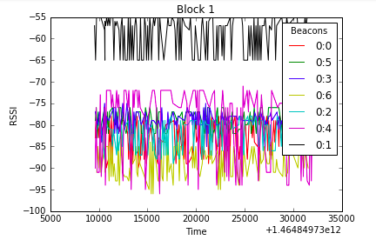

Figure 1: Raw RSSI values from Block 1

In this case, the signals should be stable because in this period of time the object is not moving. This graph demonstrates the initial instability and inaccuracy of the raw RSSI values. Next, the variance was plotted against an average RSSI value to find a quantitative way to understand noisy signals.

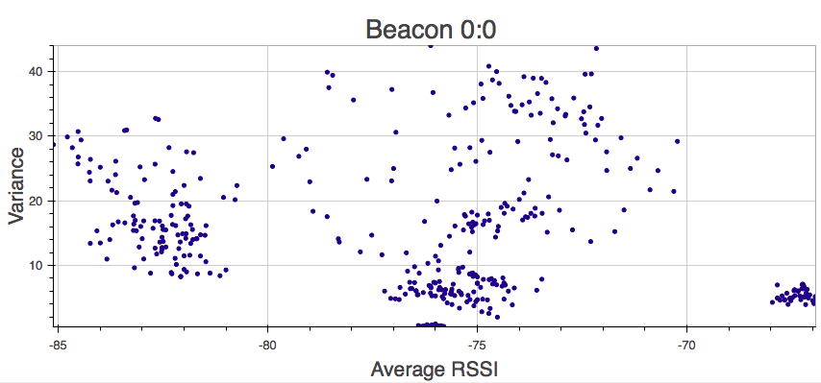

Figure 2: Variance vs. Average RSSI

There did not appear to be any correlation between the RSSI values and variance. Thus, the variance was plotted against the average distance value. The log-distance pathloss was used to calculate the distance from the RSSI values.

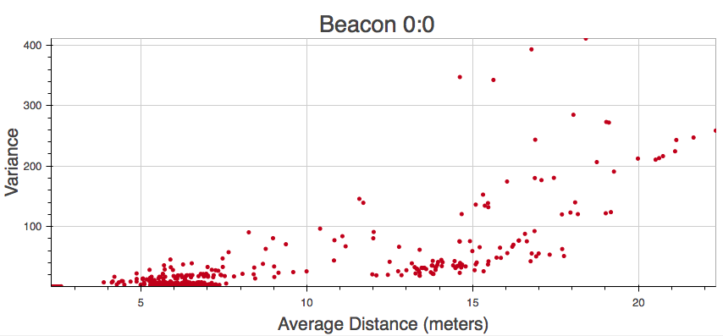

Figure 3: Variance vs. Average Distance

This plot shows a strong positive correlation between distance and variance. As the distance increases, the signals become noisier, so the variance increases. Calculated distance values appear to be stable until the distance becomes greater than 10 meters. From this point, the variance is too large to determine an accurate position. A probability density function was plotted with frequency to describe the function and distance values calculated from the RSSI values.

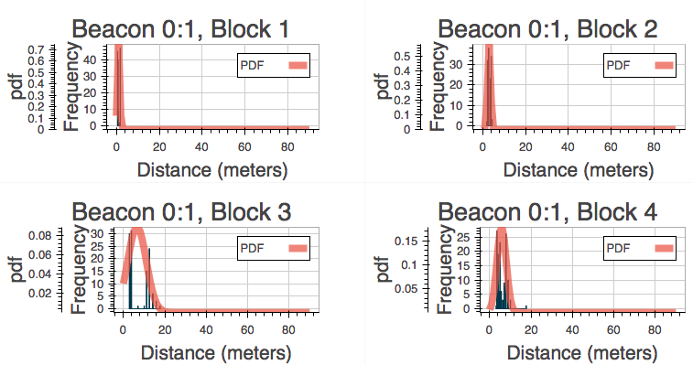

Figure 4: Probability Density Function and Frequency vs. Distance

For beacon 0:1, there exists a normal distribution within each block. Although the signals are noisy, there is a high relative likelihood for the distance to fall within the correct range.

Afterwards, filters were implemented to make the signals less noisy. First, a moving average filter was applied using a window of 2 seconds. The average RSSI and distance values were plotted against time to show the relationship between RSSI and distance.

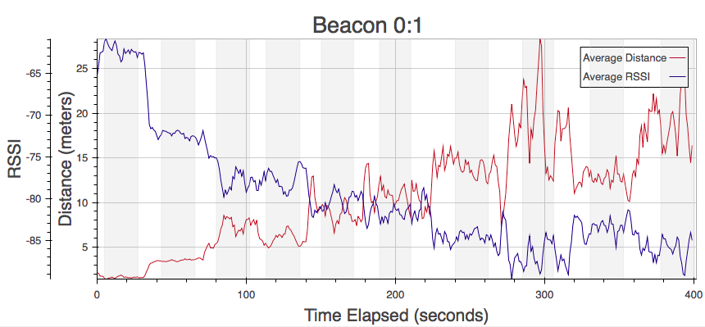

Figure 5: Average RSSI and Distance vs. Time

RSSI and distance have an inverse relationship, within distance having slightly more dramatic dips. For instance, at the 300-second mark, RSSI values range between -80 and -90 dB. Conversely, distance ranges from 10 meters to 30 meters. Although compared to Figure 1 the amount of noise has decreased, this filter does not create a smooth curve.

Two additional filters were then implemented: the finite impulse response filter and the Kalman filter. The results of these filters were plotted over the unfiltered data.

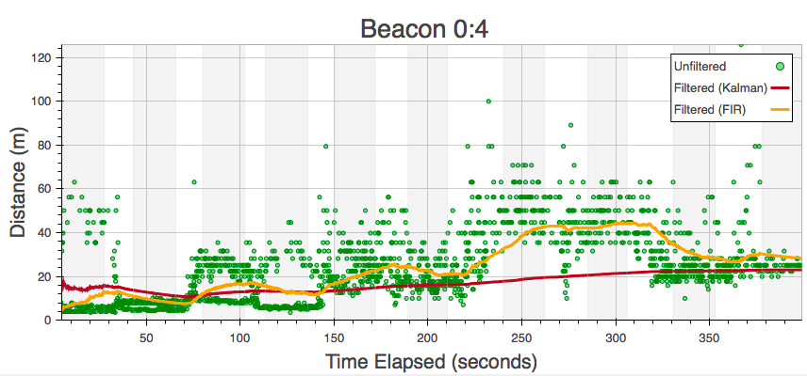

Figure 6: FIR and Kalman filters

The two filters were plotted over the unfiltered data to demonstrate the effect filtering can have on noisy data. The Kalman filter produces more stables results, with a steadier curve and much less noise. However, the FIR filter is able to have a faster response time. For example, at 230 seconds, the Kalman filter does not react quickly to the change in position, and thus has less accurate results than the FIR filter. Conversely, the FIR filter shows more visible steps between different meter marks. For example, there is a clear step between 200 and 250 seconds to show that the user was moving during this time. Consequently, the FIR filter does not have as steady of a curve; this FIR filter outputs less stable estimated locations. The FIR filter was then applied to a new set of data, in which the real time distance was also considered.

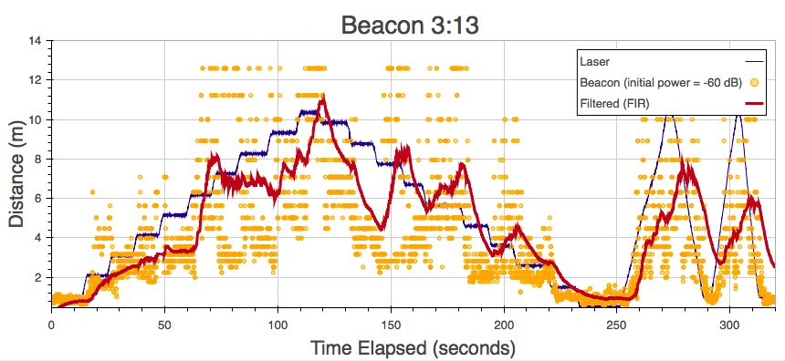

Figure 7: Real and Estimated Distance vs. Time

The FIR filter was applied to this new set of data and plotted along with the real distance, as calculated by a laser, and the calculated distance, as calculated by the beacon’s log-distance pathloss model. A threshold was also applied so outliers above 25 meters are not considered in the Kalman filtering or log-distance pathloss model. The initial power as stated in the legend represents the baseline RSSI value used. This is to standardize the comparisons since all beacons have different baseline values.

**FUTURE WORK**

The next step to further analyze the best filtration methods is to apply the Kalman filter to the latest set of data, as used in Figure 7. The comparison of the Kalman and FIR filter will help determine the optimal filtration method. Additionally, the laser distance values could be plotted against the raw RSSI values. From this, a best fit line and the line’s equation can be produced. This equation may be more accurate than the log-distance pathloss model that was used to estimate distance in Figures 1-6. Once a more accurate equation for estimated distance is produced, the filters will be more likely to produce accurate results.

**CONCLUSION**

Overall, there are many different types of filters that can be applied in a variety of ways to eliminate noise from signals. While there is usually more variance as the object distances itself from the beacon, the pdf graphs display the general overall accuracy of the beacons in determining distance. From the beacon’s RSSI values, the log-distance pathloss model exists to estimate location. While this formula outputs a distance in the general correct vicinity, another model could be created for a more accurate formula converting RSSI to distance.

**REFERENCES**

[1] Bulten, W. (2015), “Kalman filters explained: Removing noise from RSSI signals”, [Online]

[2] Bulten, W. (2015), “Lightweight Javascript library for Noise filtering using Kalman filters”, [Online]

[3] Dahlgren, E. and Mahmood, H. (2014), “Evaluation of indoor positioning based on Bluetooth Smart technology”, *Master of Science Thesis in the Programme Computer Systems and Networks*, [Online]

[4] Punskaya, E. (2013), “Design of FIR Filters”, *Institute of Neuroinformatics, University of Zürich.* [Online]

[5] Tee Jia Min, M. (2015), “Development of Indoor Patient Tracking Device”, *Department of Electrical & Computer Engineering, National University of Singapore,* Singapore

1. Johns Hopkins University Student
2. National University of Singapore Research Assistant
3. National University of Singapore Associate Professor
4. National University of Singapore Assistant Professor